**PROGRAM 2: BANKING ENTERPRISE DATABASE**

Consider the following database for a banking enterprise.

**Branch** (branch-name: String, branch-city: String, assets: real)

**BankAccount**(accno: int, branch-name: String, balance: real)

**BankCustomer** (customer-name: String, customer-street: String, customer-city: String)

**Depositer**(customer-name: String, accno: int)

**Loan** (loan-number: int, branch-name: String, amount: real)

i. Create the above tables by properly specifying the primary keys and the

foreign keys.

ii. Enter at least five tuples for each relation.

iii. Find all the customers who have at least two accounts at the *Main* branch (ex. SBI_ResidencyRoad).

iv. Find all the customers who have an account at *all* the branches located in a

specific city (Ex. Delhi).

v. Demonstrate how you delete all account tuples at every branch located in

a specific city (Ex. Bombay).

**INTRODUCTION:** This database is developed for supporting banking facilities. Details of the branch along with the accounts and loans handled by them are recorded. Also details of the depositors of the corresponding branches are maintained.

**Schema Diagram**

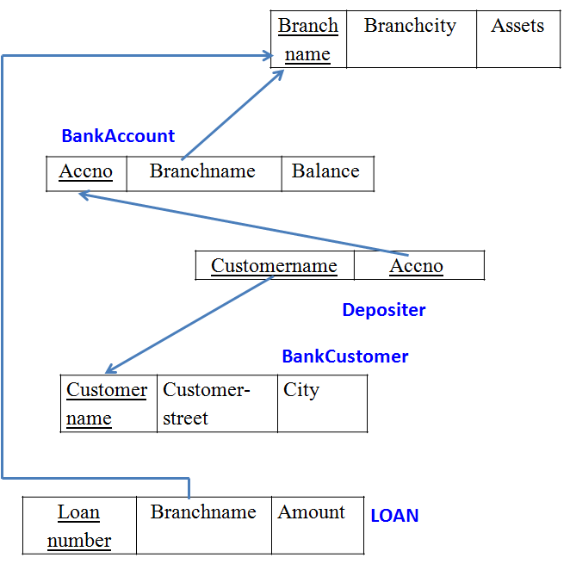

**i. Create the above tables by properly specifying the primary keys and the**

**foreign keys.**

create database Lab2;

use Lab2;

create table Branch(branch_name varchar(30),branch_city varchar(30),assests real, primary key(branch_name));

desc Branch;

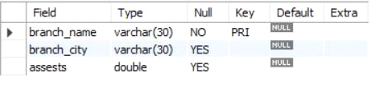

create table BankCustomer(customer_name varchar(30),customer_street varchar(30),customer_city varchar(30), primary key(customer_name));

desc BankCustomer;

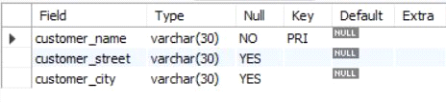

create table BankAccount(

accno int,

branch_name varchar(20),

balance real,

primary key(accno),

foreign key(branch_name) references Branch(branch_name)

);

desc BankAccount;

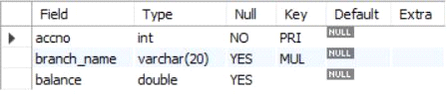

create table Depositer(

customer_name varchar(20),

accno int,

primary key(customer_name,accno),

foreign key(customer_name) references BankCustomer(customer_name),

foreign key(accno) references BankAccount(accno)

);

desc Depositer;

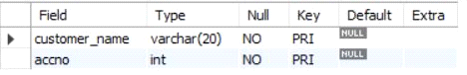

create table Loan(

loan_number int,

branch_name varchar(20),

Amount real,

primary key(loan_number),

foreign key(branch_name) references Branch(branch_name)

);

desc Loan;

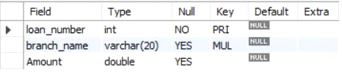

**ii. Enter at least five tuples for each relation.**

insert into Branch values('SBI_Chamrajpet','Bangalore',50000);

insert into Branch values('SBI_ResidencyRoad','Bangalore',10000);

insert into Branch values('SBI_ShivajiRoad','Bombay',20000);

insert into Branch values('SBI_ParlimentRoad','Delhi',10000);

insert into Branch values('SBI_Jantarmantar','Delhi',20000);

select *from Branch;

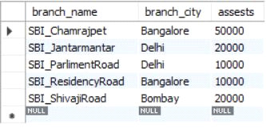

insert into Loan values(2,'SBI_ResidencyRoad',2000);

insert into Loan values(1,'SBI_Chamrajpet',1000);

insert into Loan values(3,'SBI_ShivajiRoad',3000);

insert into Loan values(4,'SBI_ParlimentRoad',4000);

insert into Loan values(5,'SBI_Jantarmantar',3000);

select *from Loan;

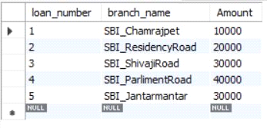

insert into BankAccount values(1,'SBI_Chamrajpet',2000);

insert into BankAccount values(2,'SBI_ResidencyRoad',5000);

insert into BankAccount values(3,'SBI_ShivajiRoad',6000);

insert into BankAccount values(4,'SBI_ParlimentRoad',9000);

insert into BankAccount values(5,'SBI_Jantarmantar',8000);

insert into BankAccount values(6, 'SBI_ShivajiRoad', 4000);

insert into BankAccount values(8, 'SBI_ResidencyRoad', 4000);

insert into BankAccount values(9, 'SBI_ParlimentRoad', 3000);

insert into BankAccount values(10, 'SBI_ResidencyRoad', 5000);

insert into BankAccount values(11, 'SBI_Jantarmantar', 2000);

select *from BankAccount;

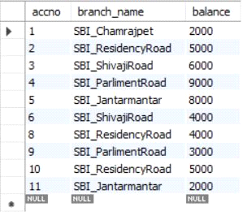

insert into BankCustomer values ('Avinash', 'Bull_Temple_Road', 'Bangalore');

insert into BankCustomer values ('Dinesh', 'Bannergatta_Road', 'Bangalore');

insert into BankCustomer values ('Mohan', 'National_College_Road', 'Bangalore');

insert into BankCustomer values ('Nikhil', 'Akbar_Road', 'Delhi');

insert into BankCustomer values ('Ravi', 'Prithviraj_Road', 'Delhi');

select *from BankCustomer;

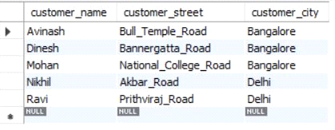

insert into Depositer values('Avinash', 1);

insert into Depositer values('Dinesh', 2);

insert into Depositer values('Nikhil', 4);

insert into Depositer values('Ravi', 5);

insert into Depositer values('Avinash', 8);

insert into Depositer values('Nikhil', 9);

insert into Depositer values('Dinesh', 10);

insert into Depositer values('Nikhil', 11);

select *from Depositer;

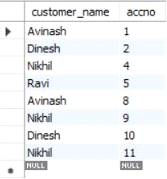

**iii. Find all the customers who have at least two accounts at the *Main* branch (ex. SBI_ResidencyRoad).**

select c.customer_name

from BankCustomer c

where exists(

select d.customer_name

from Depositer d, BankAccount ba

where

d.accno=ba.accno and

c.customer_name=d.customer_name and

ba.branch_name='SBI_ResidencyRoad'

group by d.customer_name

having count(d.customer_name)>=2

);

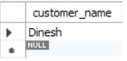

**iv. Find all the customers who have an account at *all* the branches located in a**

**specific city (Ex. Delhi).**

select distinct d.customer_name from Depositer d where exists( select * from BankAccount ba

where ba.accno=d.accno and exists (select * from Branch b where b.branch_name = ba.branch_name and b.branch_city='Delhi'));

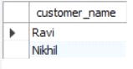

**v. Demonstrate how you delete all account tuples at every branch located in**

**a specific city (Ex. Bombay).**

delete from BankAccount where branch_name in (select branch_name from branch where branch_city = 'Bombay');

select *from BankAccount;

